School Student Behaviour Support Plan
PB4L
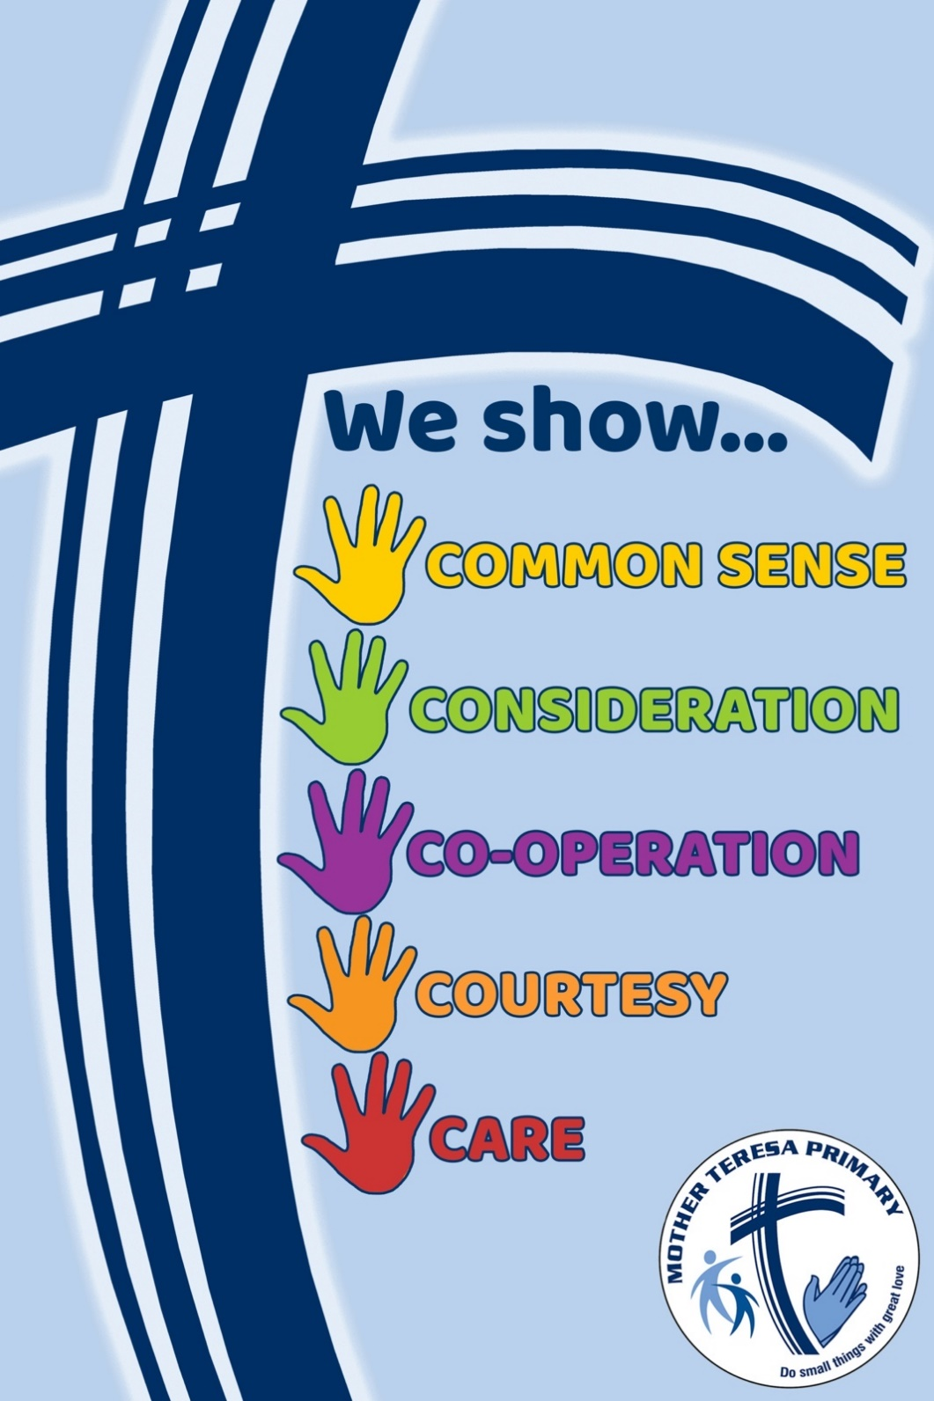
- Introduction

Our community of Mother Teresa Primary School, as part of Brisbane Catholic Education (BCE) schools, values an inclusive approach to student support to enable students to successfully complete their studies. We are entrusted to nurture and support students in a safe and welcoming environment that is grounded in our Catholic faith in which stewardship and advocacy are key values. As Catholic educators, we hold fundamental beliefs that are foundational to our work with students, parents, colleagues and the broader community. As such we value: our Catholic Christian tradition; dignity and justice for all; Catholic Christian community; high quality learning; collaboration and subsidiarity (shared wisdom); creativity; stewardship; and a mutual accountability. (Brisbane Catholic Education Strategic Renewal Framework 2012-2015) In Catholic schools the goal of formation in right behaviour and respectful relationships occurs in a supportive community where students are provided with models of Christ-centred living and where they can learn from their mistakes and build and restore relationships in a climate of safety, acceptance and reconciliation.
- School Vision Statement

As Christians we are called to care for creation, for present and future generations.
Through personal conversion and Catholic Social Teaching

​We Teach by:​​
​Encouraging and supporting Eco-Literacy within Learning and Teaching Programs and Professional
Learning​

We Challenge by​:
Embedding and aligning the principles of sustainability and environmental stewardship within renewal processes

We Transform b​y:
Promoting personal and communal ecological conversion and establishing community partnerships as we move towards living an ecological vocation

Rationale of Vision Statement
The introduction lines to the vision statement '...we are called to care for creation' reflects a Catholic perspective of the Bruntland definition for sustainability, which states that “Humanity has the ability to make development sustainable - to ensure that it meets the needs of the present without compromising the ability of future generations to meet their needs.” (WCED 1987)

'...we are called to care for creation' utilises the Vision for Catholic Education in the Archdiocese and matches its key elements with the literature and success practice in ecological sustainability in education.

Teach ~ focuses upon classroom learning and teaching
Challenge ~ focuses upon whole of school change and organisational culture
​​Transform ~ focuses on embedding change and in the wider community

- Vision for Learning
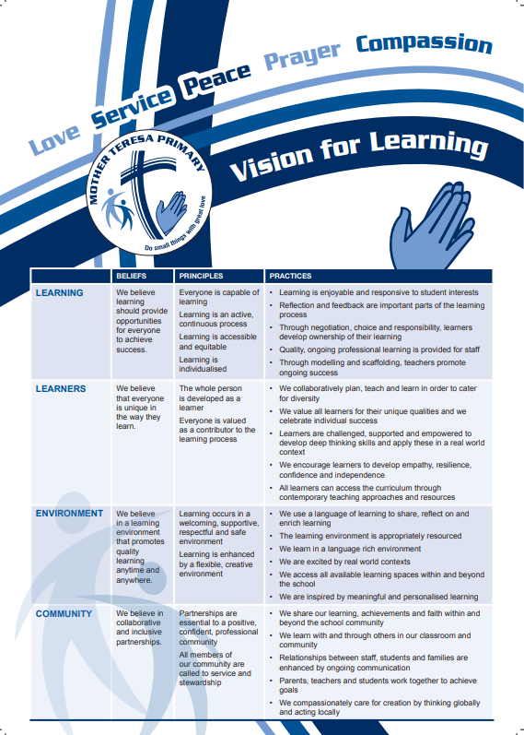

- Beliefs about learning

Mother Teresa primary school provides students with real world, hands on contexts to apply their learning. Teachers and staff continually teach, monitor and assess through a balance of focused teaching, small group work and individual or whole class learning opportunities. Students engage with the relevant content from the Australian Curriculum and are immersed in a wide range of learning experiences that challenges thinking and stimulates new ideas. Through choice and collaboration students become problem finders and investigate and create solutions utilising technologies available and accessing a range of resources in the learning environment. These personalised tasks enable students to demonstrate their new knowledge, skills and understandings from a range of curriculum areas. Through the process of planning, reflecting on and evaluating their ideas, students become responsible learners. This rich learning caters for all learning styles and gives real purpose for students to develop thinking skills necessary to become effective and respectful members of our global community.
- Our Approach – Positive Behaviour 4 Learning
What is Positive Behaviour 4 Learning? PB4Learning is about people, practices and processes – it is not a program but the way we do work. A focus on learning, capability building, wise and thorough use of data, and identifying and spreading good evidence-based practice are all integrated into the PB4Learning strategy.
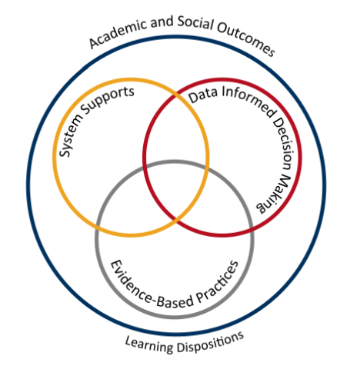

Adapted from School-wide Positive Behaviour Support: implementers’ blueprint and Self-Assessment, by OSEP Center On Positive Behavioral Interventions and Supports, 2004, Eugene OR: Lewis
Theoretical and Conceptual Characteristics
The theoretical and conceptual understandings of PB4L are firmly linked to Behavioural Theory and Applied Behavioural Analysis (Carr et al., 2002). This perspective emphasises that observable behaviour is an important indicator of what individuals have learned and how they operate in their environment, behaviour is learned and rule governed, environmental factors are influential in determining whether a behaviour is likely to occur and new and alternative pro-social behaviours can be taught (Sugai & Horner, 2002; Sugai et al., 2008).
Continuum of Support and Key Features
An important component of PB4L is the adoption of a continuum of behavioural supports that, like academic instruction, acknowledges that students will need differing levels of behavioural interventions and supports to be successful at school. Within the continuum there are three levels of support. The first level focuses on ‘universal’ behavioural and academic supports for all students. Here the focus is on prevention of problem behaviours, providing early intervention for those at risk and creating positive learning environments across all settings in the school. Research has shown that approximately 80-85% of students will respond to proactive universal supports, display the desired appropriate behaviours, and have few behaviour problems (Horner & Sugai, 2005; Lewis, Newcomer, Trussell & Ritcher, 2006). The second level focuses on students who continue to display problem behaviour even with the universal supports in place. Through the use of data, students are identified early, before problem behaviours become intense or chronic, and receive targeted supports, such as small group social skill instruction, academic supports and self-management strategies (Sailor et al., 2013). Finally, the third or tertiary level of support is intensive or individualised. These students will require highly individualised behaviour support programs based on a comprehensive behavioural assessment, which at times, will include mental health professionals and family and community services.

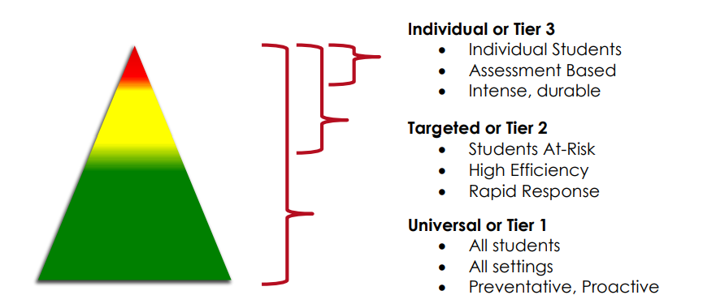

By building a connected continuum, everyone in the school is aware of how each level of support is connected to the universal systems i.e. every targeted and individualised intervention uses the universal set of behavioural expectations to increase the likelihood of maintenance and generalisation to other context.
Universal supports – Tier 1
A relentless focus on learning for all students
Clarity: Our Expectations
School-wide expectations encourage consistent communications and establish an effective verbal community for all staff and students and across all settings. Agreed upon student expectations promote consistency across the staff and school community and help develop similar tolerance levels. At Mother Teresa Primary School, our school-wide expectations are:
We show CARE
We show COMMON SENSE
We show COURTESY
We show CONSIDERATION
We show COOPERATION
Our school-wide matrix determines the social skills and behaviours we expect all students and staff to learn, practice and demonstrate. They allow us to teach proactively and to provide students and parents with a positive message about discipline.

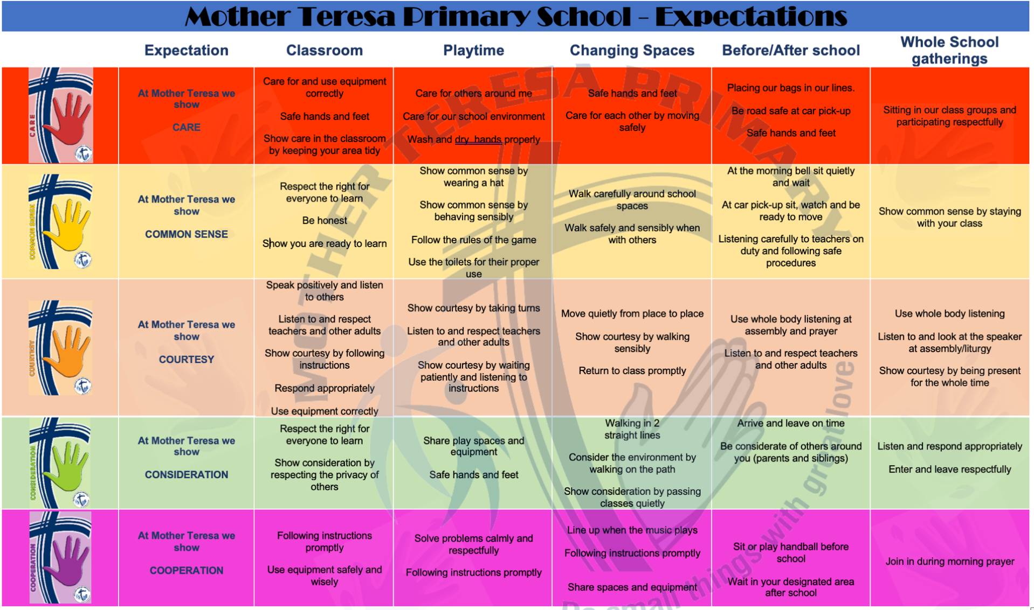

- Teaching expected behaviours

Positive behaviours and dispositions underpin all general capabilities in the Australian Curriculum. Personal and social capability encompasses students' personal/emotional and social/relational dispositions, intelligences, sensibilities and learning, developing effective life skills for students, including understanding and handling themselves, their relationships, learning and work.
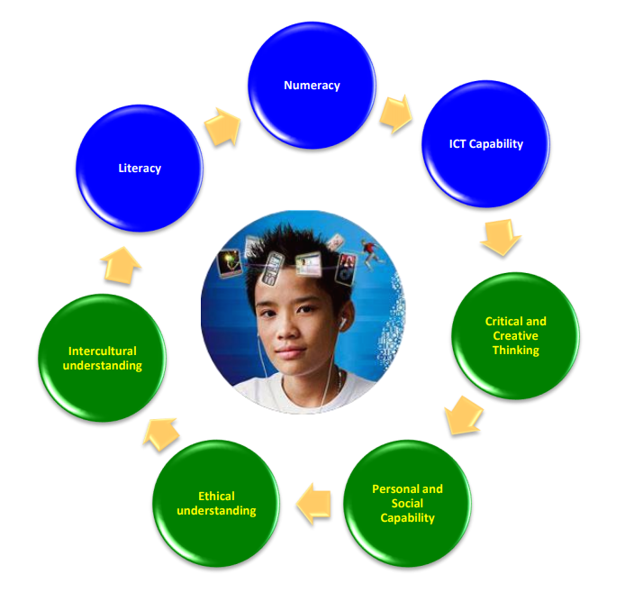
Process
Research has shown that Positive Behaviour 4 Learning improves a school’s environment and helps keep students and teachers in safe and productive classrooms by:
- reducing disciplinary incidents
- improving attendance rates
- increasing students’ sense of belonging and safety
- supporting improved academic outcomes
- improving interpersonal relationships
Introducing, modelling, and reinforcing positive social behaviour is an important step of a student's educational experience. Teaching behavioural expectations and acknowledging students for following them is a much more positive approach than waiting for misbehaviour to occur before responding.
- Teach – introduce the expected behaviour and why it is important
- Show – demonstrate or model the rule
- Practice – role play expected behaviour in relevant contexts
- Monitor - Pre correct - Supervise - Provide positive feedback
- Re-teach – practice throughout the day/week/month/year (Teaching and reinforcing. Look at other ways of doing it).
Explicit Teaching
Explicit teaching provides a consistent approach across the whole school
- An agreed upon and common language approach to behaviour management
- The Behaviour Expectation Matrix of positively stated expectations for students and staff that is explicitly taught by teachers which is displayed throughout the school.
- Procedures for teaching the expectations
A continuum of procedures for encouraging expected behaviours and discouraging inappropriate behaviours including;
- School wide reward systems
- Classroom reward systems – extrinsic and intrinsic
- Expected behaviour flowchart
Practices:
Student behaviour is supported with evidence based interventions and strategies by providing:
- Positive expectations; explicitly taught and encouraged
- Active supervision by ALL staff
- Pre-corrections and reminders
- Positive reinforcement and acknowledgements
- Contextual adjustments – alter environment to fit issues
Behaviour Expectation Matrix
The Behaviour Expectation Matrix translates Good Shepherd rules of expected behaviours. Expected behaviours are to be explicitly taught in the classrooms. The matrix will be displayed in each classroom around the school. It will be referred to and discussed regularly with the students at Good Shepherd.
Focus: Teaching Expected Behaviours
Effective instruction requires more than providing the rule–it requires instruction, practice, feedback, re-teaching, and encouragement (Sprague & Golly, 2005). Instruction takes place each day, throughout the day, all year long.
Feedback: Encouraging Expected Behaviour
It is important to follow desired behaviours with consequences that are reinforcing to most students, such as specific positive feedback, along with other forms of reinforcement. Our systems encourage and motivate students, both as they are learning the expected behaviours and then to maintain these skills and dispositions as students become more fluent with their use. Specifically, our encouragement system utilises effective, specific positive feedback, adult attention both contingent and non-contingent and a tangible reinforcement system.
Non-contingent adult attention is provided regardless of performance and includes such things as greeting, smiles and conversations. While contingent adult attention is provided based upon the performance of an identified behaviour. Gotchas and Acts of Kindness rewards fall into this category. Both types of attention create a positive school climate and builds rapport and relationships, helping students to learn.
With specific positive feedback, adults are recognising attainment of specified performance criteria, effort or success at tasks that are difficult for the student. Such feedback is given frequently when a student is learning a new skill and intermittently when a student is maintaining the skill or generalising it to a new context.
These components enable staff to effectively recognise and encourage students when they display expected behaviours and contribute to the creation of a positive school environment.
- Targeted Supports

Targeted interventions play a key role in supporting students at risk of academic and social problems and may prevent the need for more intensive interventions (Sailor et.al. 2009). These students consistently have trouble with low level but disruptive behaviours that are detrimental to instruction and interfere with their own learning. Targeted inventions should be timely and responsive and use similar strategies and social curriculum across a group of students.
Students are identified proactively, either through discipline data, attendance data, and teacher nomination or through a screening process. Our targeted supports have systems in place to monitor student progress, make modifications, and gradually decrease support as student behaviour and engagement improves.

- Responding to inappropriate Behaviours

The best defence is always a great offence
Even with our positive approach to teaching and supporting appropriate behaviour, some problem behaviour will still occur. For some students, they do not know how to perform the expected behaviour or don’t know it well enough to routinely use it at the appropriate times. For other students, they are not sufficiently motivated or invested in using the appropriate behaviour even when they understand what is expected.
The process of responding to problem behaviour is much like an error analysis, which is commonly used for academic work. Students who have a “skills deficit” will need more explicit instruction and practice while students who have a “performance deficit” need more prompts and cues to highlight the need for the replacement behaviour in context and may need more intense reinforcement when they use the replacement behaviour.
A Continuum of Responses
To correct behavioural ‘errors’, we have a system in place that enables staff to efficiently and effectively respond to a range of inappropriate behaviours, from relatively minor ones, to chronic persistent minor behaviours and to more serious and major problems. This continuum thinking begins with clarity between those behaviours that can and should be managed by staff, within the context of the classroom and non-classroom settings, and those that are serious enough to warrant an office referral. The definitions of teacher managed behaviours (minors) and office managed behaviours (majors) are identified below.
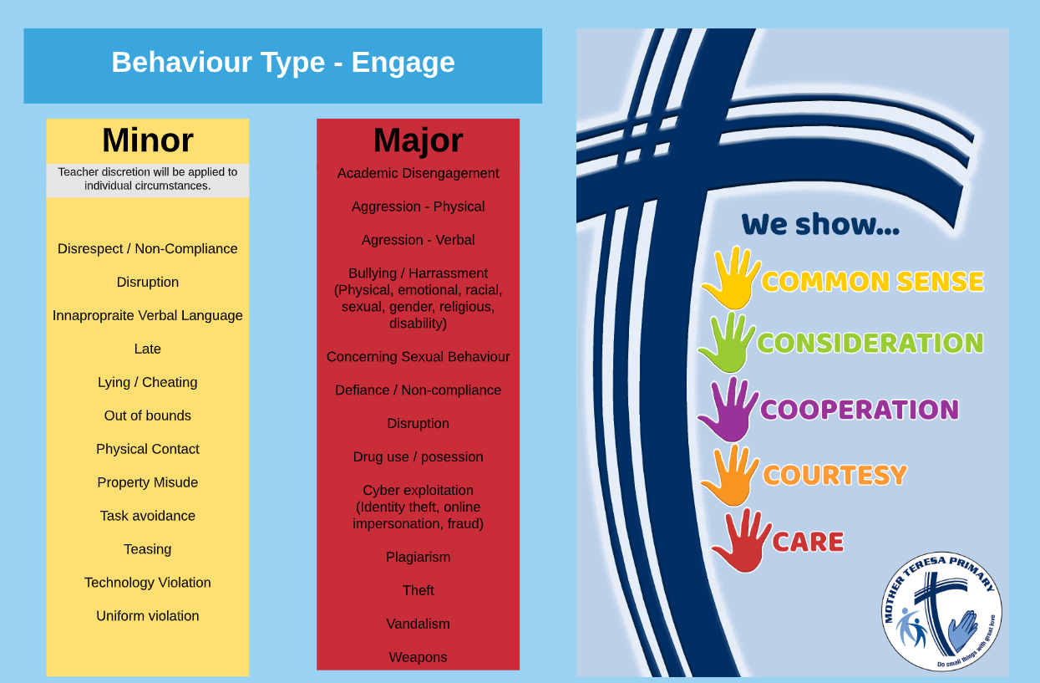
Although the teacher is the key problem solver when addressing minor behaviours, they can and should collaborate and share creative strategies with, families and colleagues. Teachers typically address minor behaviours using best practices that include correction and re-teaching. As with all strategies to address inappropriate behaviour, they should be done privately and with an instructional demeanour.
If the inappropriate behaviour persists or intensifies, staff may cease using correctional strategies and utilise crisis prevention strategies with the intent of preventing the behaviour from escalating beyond what can be appropriately managed in the instructional environment.
Crisis prevention strategies may include giving a student time away from their regular program in a separate area in the classroom, in another supervised classroom or in the office. The intent of the ‘time away” is for a student to regain control of their own behaviour.
For “Office managed” behaviours, the behaviour is more serious or ongoing disruption, concerns for safety for the student or others, or is a potentially illegal behaviour. This will typically result in actions taken by the School Leadership that may include more intensive teaching, restitution activities, strategies to help the student handle future situations or parent/carer conferences.
- Monitoring inappropriate behaviour
Our monitoring system for both major and minor behaviours assist us in making decisions about when to engage other supports to address the problem. Typical consideration would include:
- The student losing instructional time because of his/her behaviour.
- The behaviour is occurring frequently, requiring substantial teacher time
- The intensity of the behaviour draws attention of those close-by causing disruption to activities.
- The student is not responding to universal supports
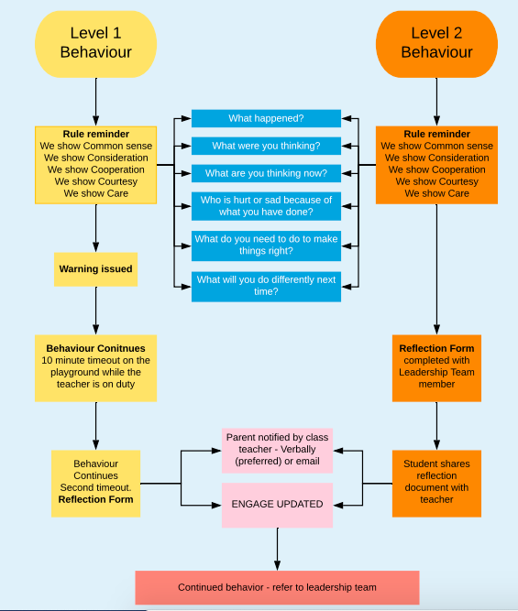
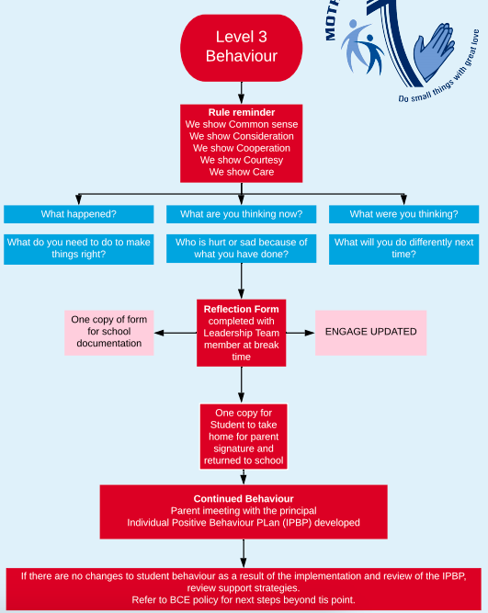

- Formal Sanctions
It is an expectation that formal sanctions (detention/suspension/exclusion) are only imposed when all other reasonable steps to deal with the situation have been taken. The proposed action appropriately balances the best interests of the student and the safety and the right to learn of other members of the school community. Mother Teresa follows Brisbane Catholic Education processes that outlines the rationale for using a suspension in its context, details about the process, including parent notification and re-entry processes.
Formal sanctions include the following:
- Detention
- Suspension
- Negotiated Change of School
- Exclusion
Details of the formal sanctions can be found in the BCE SBS: Guidelines, Regulations and Procedures (pp. 33- 44). It is expected that formal sanctions will be imposed only when all other reasonable steps to deal with the situation have been taken, unless the situation is serious and immediate. The proposed action should appropriately address the best interests of the student and the security, safety and learning environment of other members of the school community. Following segregation, re-entry consultation will occur with the student to provide feedback and restorative planning and support. Discussions and ongoing evaluation may be undertaken in collaboration with appropriate available support networks.
The processes involved in formal sanctions are intended to achieve the following objectives:
- To protect the rights of the students, staff and learning community;
- To help find ways to negotiate, with the student, a plan for change to acceptable patterns of behaviour;
- To keep the parents/caregivers of the student informed and, if possible, engage them in the negotiations to secure a change to acceptable patterns of behaviour by the student;
- To safeguard the right of teachers to be able to teach without inappropriate disruption;
- To safeguard the right of other students to learn without inappropriate disruption; • To ensure that sufficient and accurate documentation is made and kept
- To indicate sources of assistance for schools;
- To provide the school community with an explicit statement of disciplinary sanctions and procedures; and
- To protect Brisbane Catholic Education and its schools against allegations of proceeding improperly.
The processes associated with formal sanctions assume that:
- Students, parents/caregivers and teachers have been fully informed about the school’s Behaviour Learning Plan and code of student conduct (School Rules).
- Teachers are fully conversant with the school’s process for formal sanctions
- Parents/caregivers have been informed that a serious problem exists as soon as it is identified
- Adequate consultation has occurred with all stakeholders to best support the student.

